**Jesus has given me the Holy Spirit**

**Reading: from Acts 1:1-8**

After Jesus’ suffering and death, he appeared to his followers. In many ways, he proved to them that he was alive.

One day Jesus was eating with them. He gave them a command. “Do not leave Jerusalem,” he said. “Wait for the gift my Father promised. You have heard me talk about it. John baptised with water. But in a few days you will be baptised with the Holy Spirit.

You will receive power when the Holy Spirit comes on you. Then you will tell people about me in Jerusalem, and in all Judea and Samaria. And you will even tell people about me from one end of the earth to the other.”

After Jesus said this, he was taken up to heaven. The apostles watched until a cloud hid him from their sight.

**Thought about the reading**

Before he died, Jesus promised his followers that his Father in heaven would send them the Holy Spirit. He reminded them again just before he went up to heaven. On the day of Pentecost, Jesus kept his promise, and the Holy Spirit came down on his followers. But this promise is for all his followers who believe in him, including you and me.

Jesus is in heaven now, but through the Holy Spirit who lives with us, Jesus is still with us and helps us.

The Holy Spirit does three things:

1. The Holy Spirit keeps us company. He is always there to help.
2. The Holy Spirit teaches us about Jesus. He can help us when we don’t understand, and he reminds about the things we have learnt.
3. The Holy Spirit helps us to follow Jesus. He shows us the things Jesus wants us to do. He also shows us the things we have done wrong and helps us to say sorry.

Jesus promised to give his Holy Spirit to everyone who believed in him. He is always with us to help us.

**Prayer**

Dear Jesus, thank you for your promise of the Holy Spirit. Please send your Spirit to me.

Holy Spirit, thank you that you live in me, and you are always with me. Please help me to learn about Jesus. Please help me to follow him.

Amen

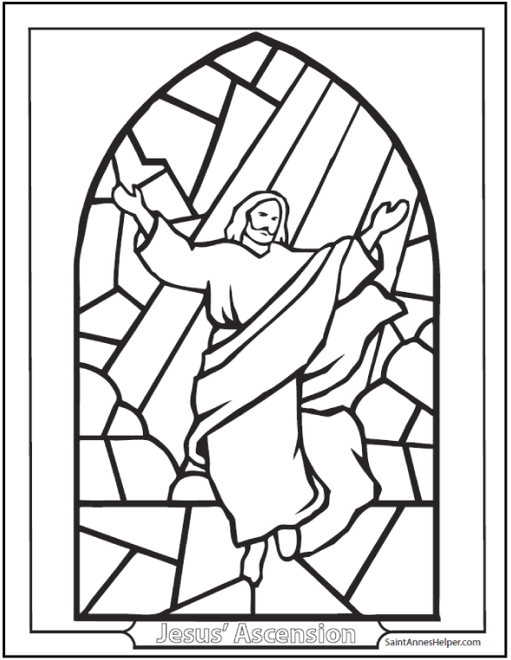

**Cambridge Causeway**

Autumn 2024

Bible Study notes

**What Jesus has done for me**

**2. Jesus has given me the Holy Spirit.**

By Chrissy Cole